Machine Learning筆記_Andrew Ng

## Week1

What is Machine Learning?

What is Machine Learning?

Two definitions of Machine Learning are offered. Arthur Samuel described it as: "the field of study that gives computers the ability to learn without being explicitly programmed." This is an older, informal definition.

Tom Mitchell provides a more modern definition: "A computer program is said to learn from experience E with respect to some class of tasks T and performance measure P, if its performance at tasks in T, as measured by P, improves with experience E."

Example: playing checkers.

E = the experience of playing many games of checkers

T = the task of playing checkers.

P = the probability that the program will win the next game.

In general, any machine learning problem can be assigned to one of two broad classifications:

Supervised learning and Unsupervised learning.

Supervised Learning

In supervised learning, we are given a data set and already know what our correct output should look like, having the idea that there is a relationship between the input and the output.

Supervised learning problems are categorized into "regression" and "classification" problems. In a regression problem, we are trying to predict results within a continuous output, meaning that we are trying to map input variables to some continuous function. In a classification problem, we are instead trying to predict results in a discrete output. In other words, we are trying to map input variables into discrete categories.

**Example 1:**

Given data about the size of houses on the real estate market, try to predict their price. Price as a function of size is a continuous output, so this is a regression problem.

We could turn this example into a classification problem by instead making our output about whether the house "sells for more or less than the asking price." Here we are classifying the houses based on price into two discrete categories.

**Example 2**:

(a) Regression - Given a picture of a person, we have to predict their age on the basis of the given picture

(b) Classification - Given a patient with a tumor, we have to predict whether the tumor is malignant or benign.

Unsupervised Learning

Unsupervised learning allows us to approach problems with little or no idea what our results should look like. We can derive structure from data where we don't necessarily know the effect of the variables.

We can derive this structure by clustering the data based on relationships among the variables in the data.

With unsupervised learning there is no feedback based on the prediction results.

**Example:**

Clustering: Take a collection of 1,000,000 different genes, and find a way to automatically group these genes into groups that are somehow similar or related by different variables, such as lifespan, location, roles, and so on.

Non-clustering: The "Cocktail Party Algorithm", allows you to find structure in a chaotic environment. (i.e. identifying individual voices and music from a mesh of sounds at a [cocktail party](https://en.wikipedia.org/wiki/Cocktail_party_effect)).

Model Representation

To establish notation for future use, we’ll use x^{(i)}*x*(*i*) to denote the “input” variables (living area in this example), also called input features, and y^{(i)}*y*(*i*) to denote the “output” or target variable that we are trying to predict (price). A pair (x^{(i)} , y^{(i)} )(*x*(*i*),*y*(*i*)) is called a training example, and the dataset that we’ll be using to learn—a list of m training examples {(x^{(i)} , y^{(i)} ); i = 1, . . . , m}(*x*(*i*),*y*(*i*));*i*=1,...,*m*—is called a training set. Note that the superscript “(i)” in the notation is simply an index into the training set, and has nothing to do with exponentiation. We will also use X to denote the space of input values, and Y to denote the space of output values. In this example, X = Y = ℝ.

To describe the supervised learning problem slightly more formally, our goal is, given a training set, to learn a function h : X → Y so that h(x) is a “good” predictor for the corresponding value of y. For historical reasons, this function h is called a hypothesis. Seen pictorially, the process is therefore like this:

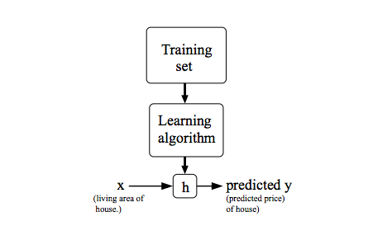

When the target variable that we’re trying to predict is continuous, such as in our housing example, we call the learning problem a regression problem. When y can take on only a small number of discrete values (such as if, given the living area, we wanted to predict if a dwelling is a house or an apartment, say), we call it a classification problem.

Cost Function

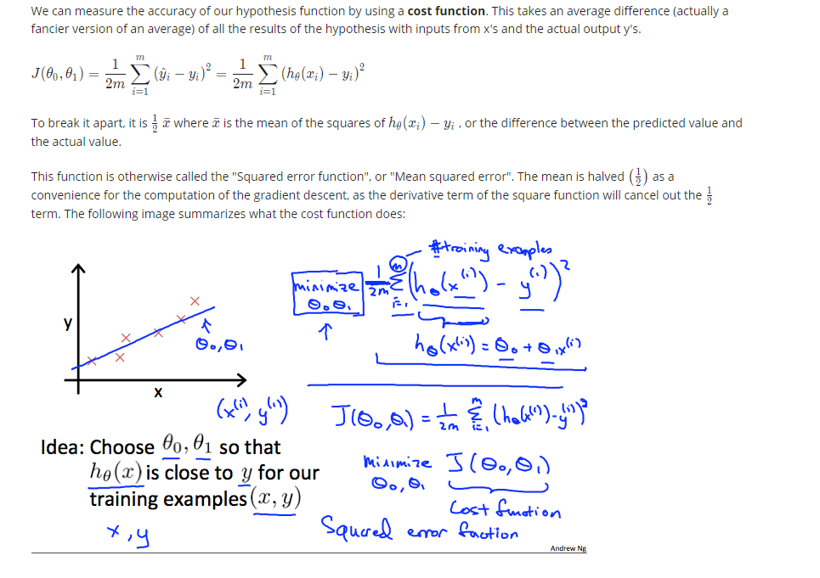

Cost Function - Intuition

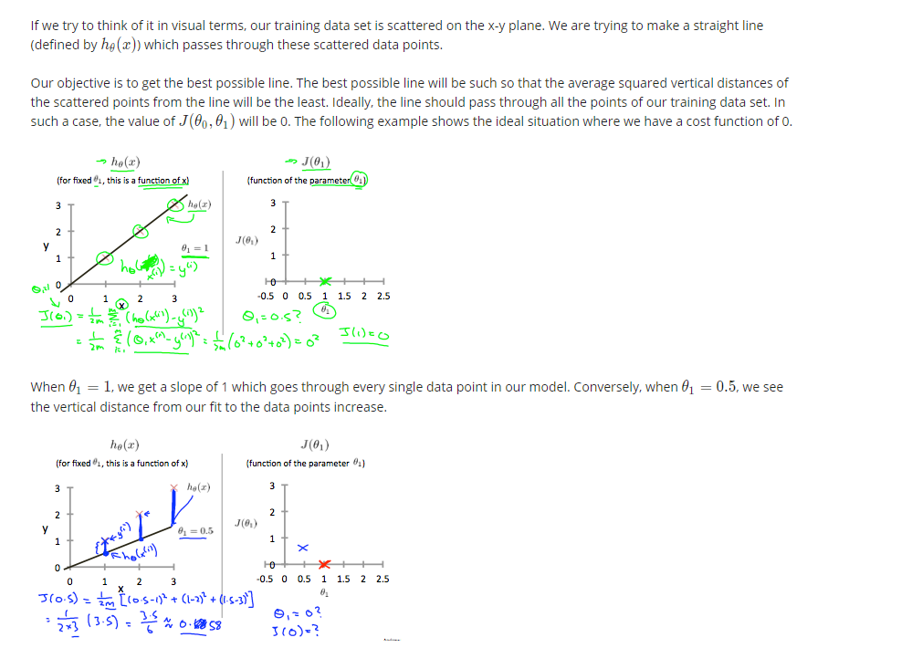

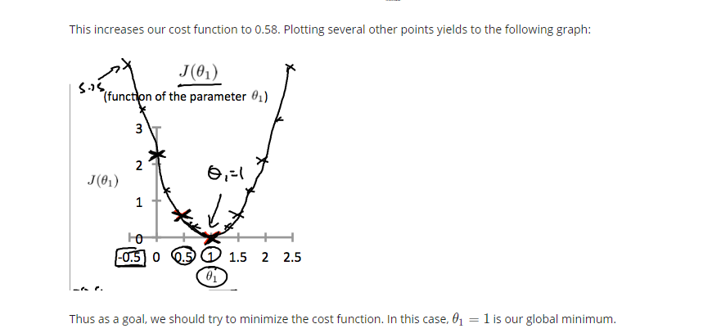

Gradient Descent

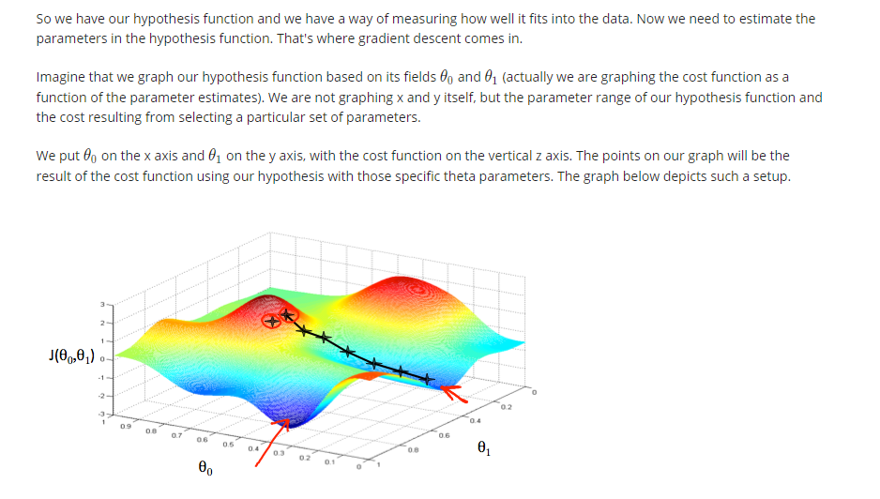

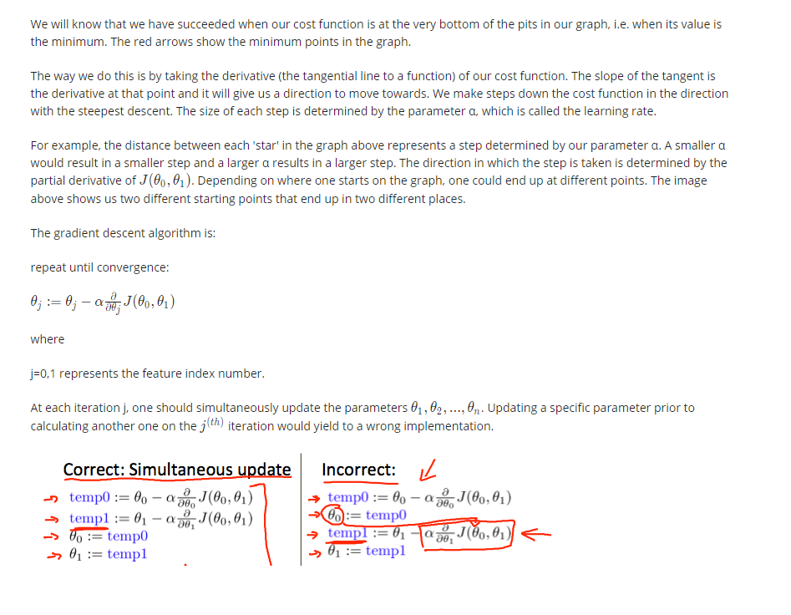

Gradient Descent Intuition

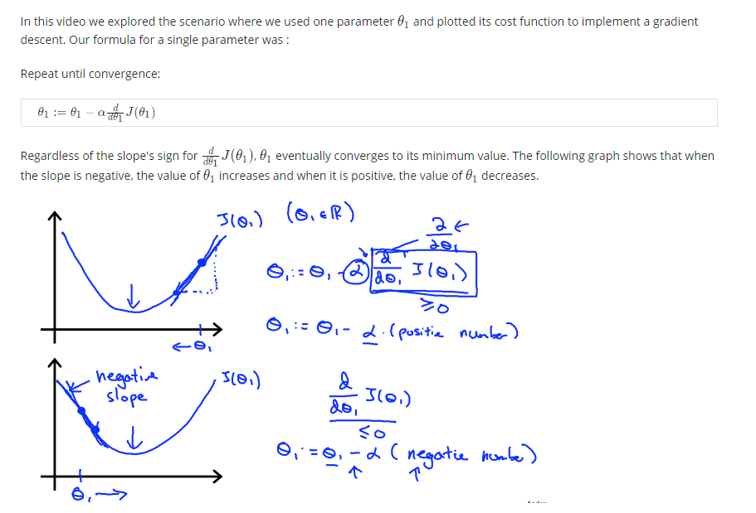

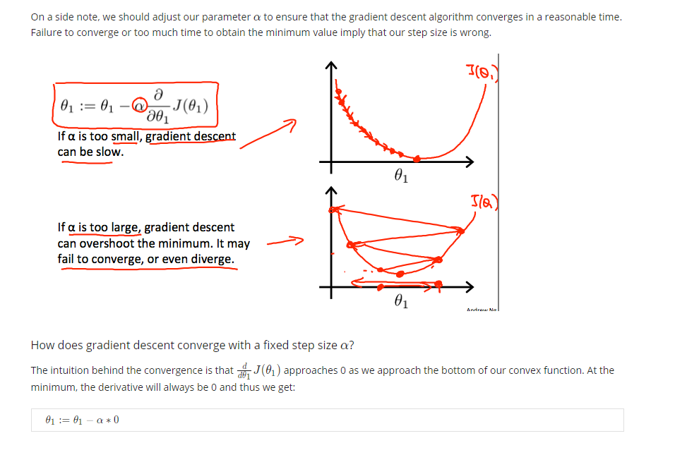

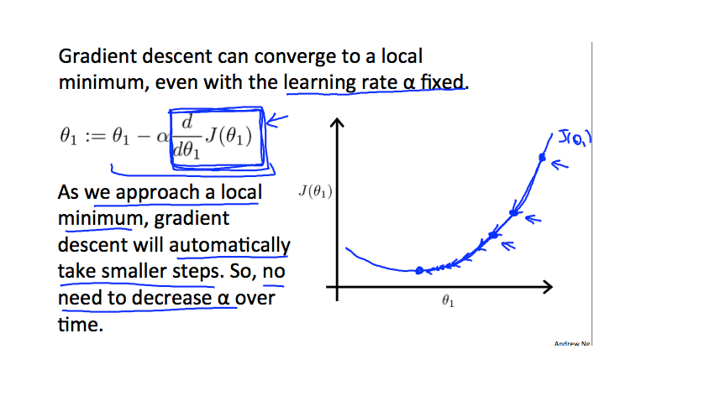

Gradient Descent For Linear Regression

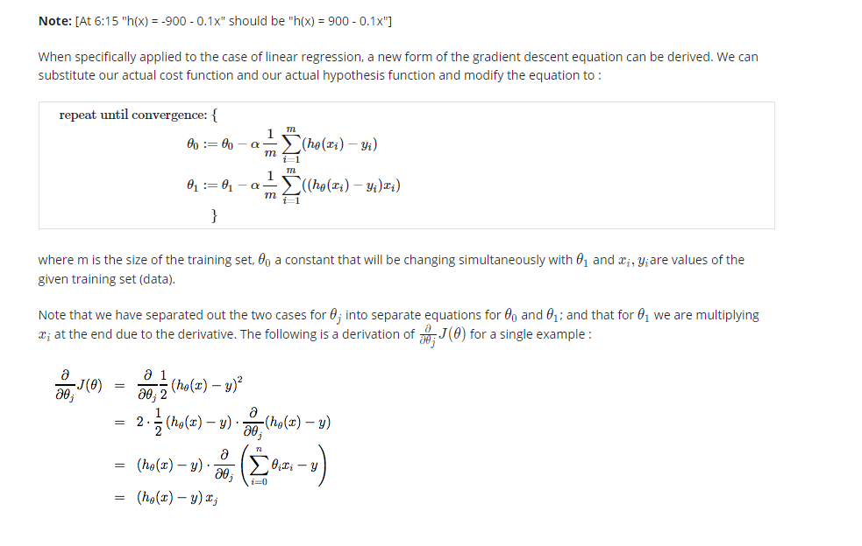

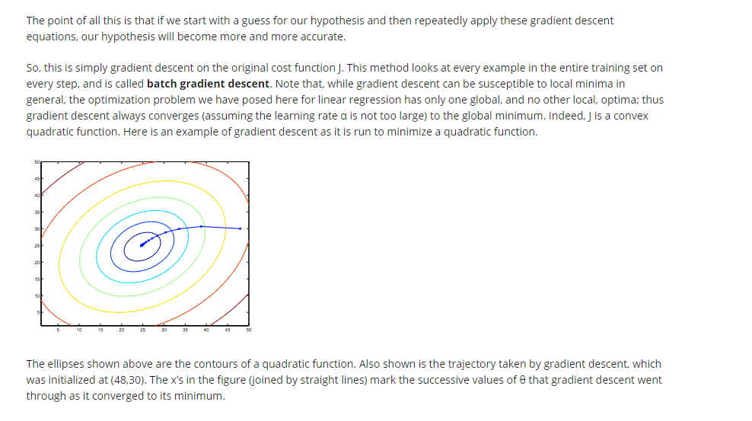

Matrices and Vectors

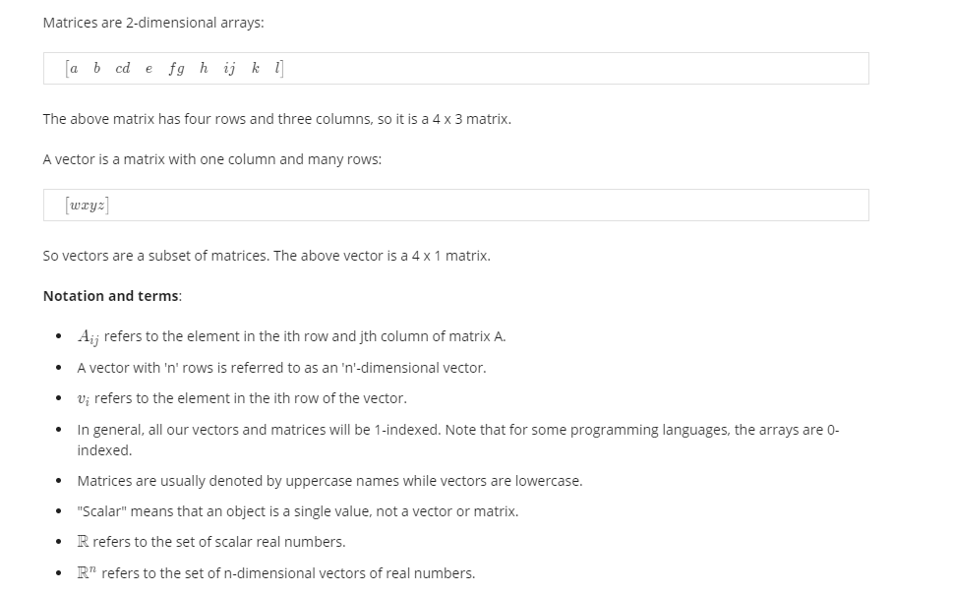

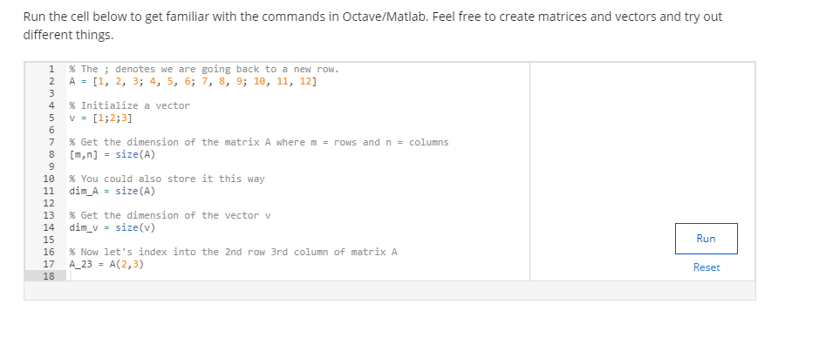

Addition and Scalar Multiplication

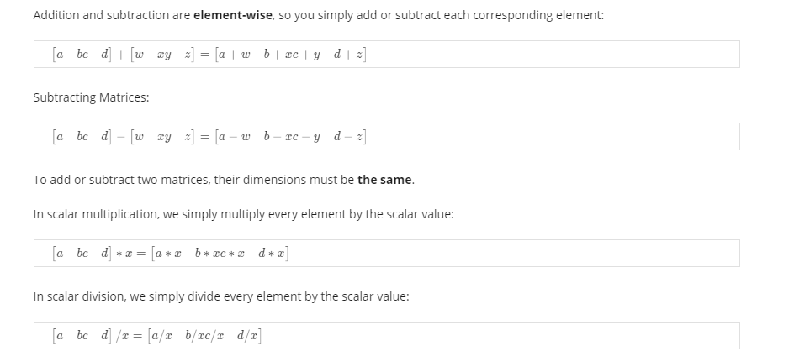

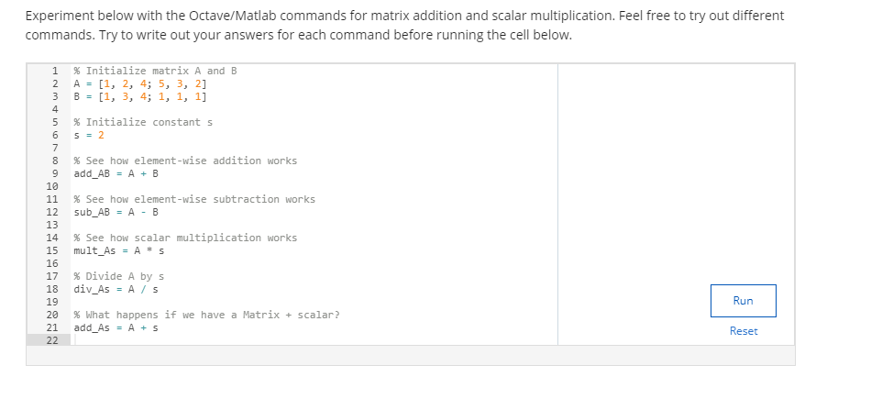

Matrix-Vector Multiplication

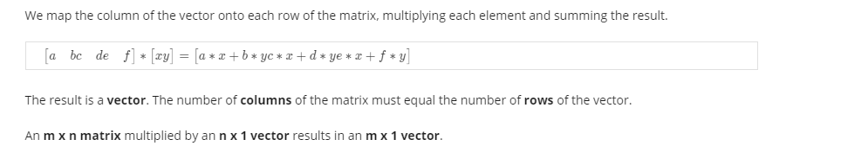

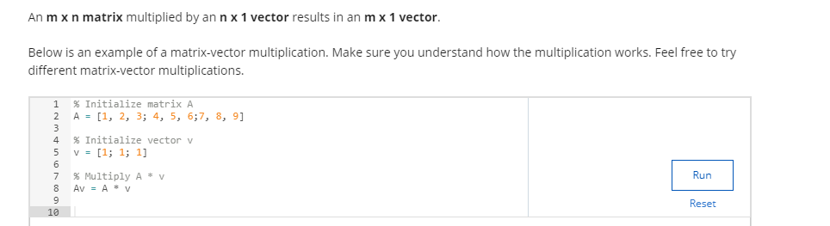

Matrix-Matrix Multiplication

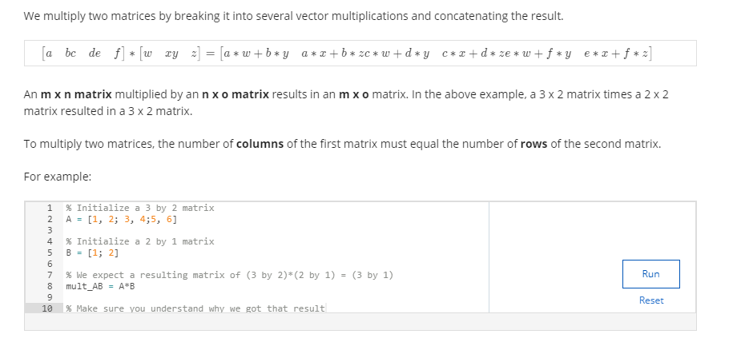

Matrix Multiplication Properties

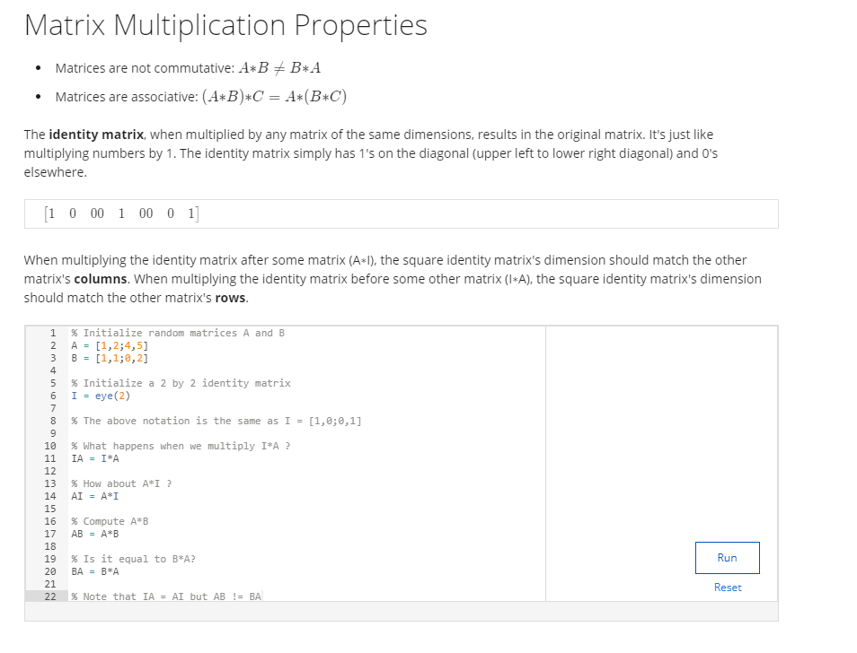

Inverse and Transpose

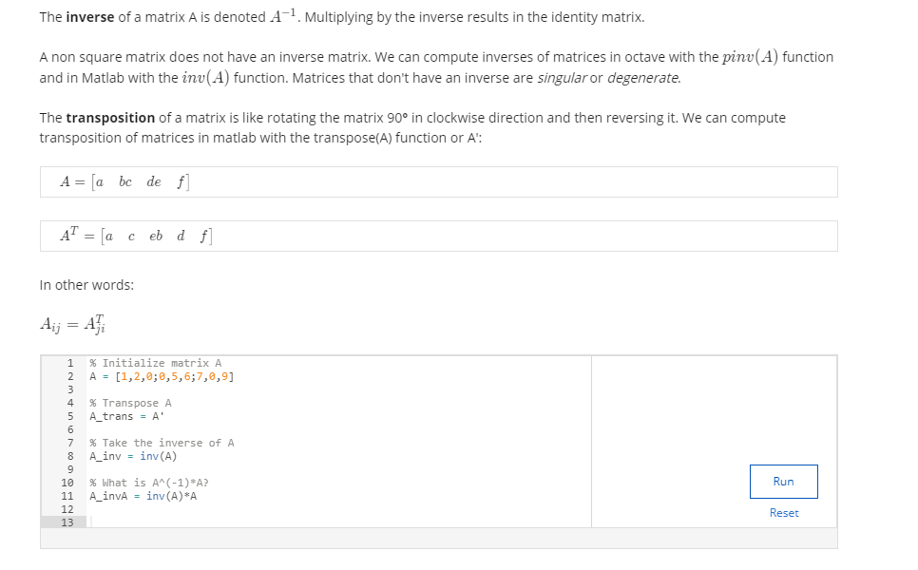

## Week2

Multiple Features

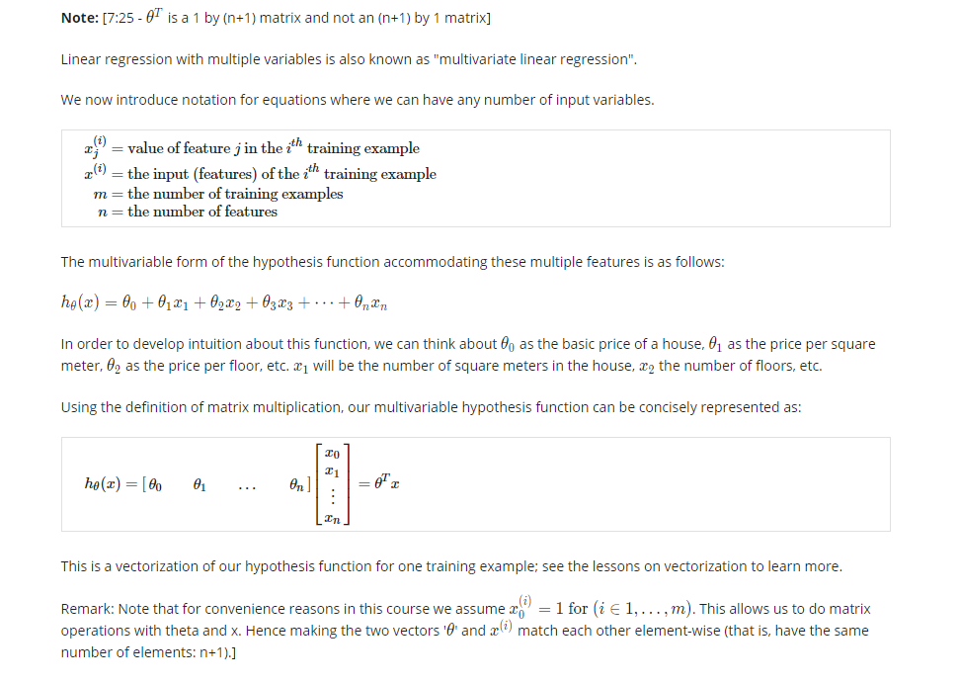

Gradient Descent For Multiple Variables

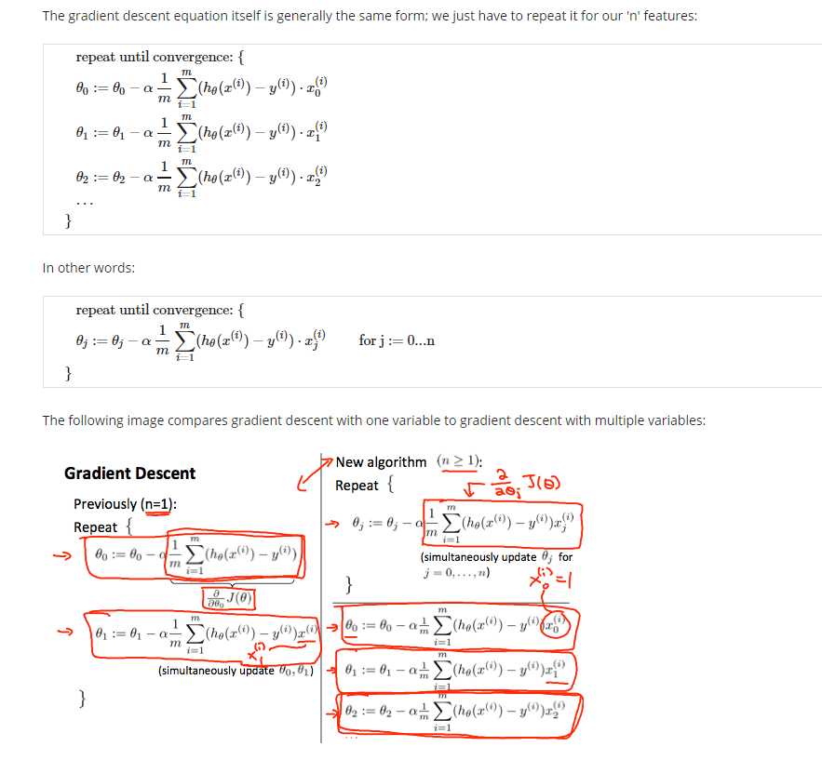

Gradient Descent in Practice I - Feature Scaling

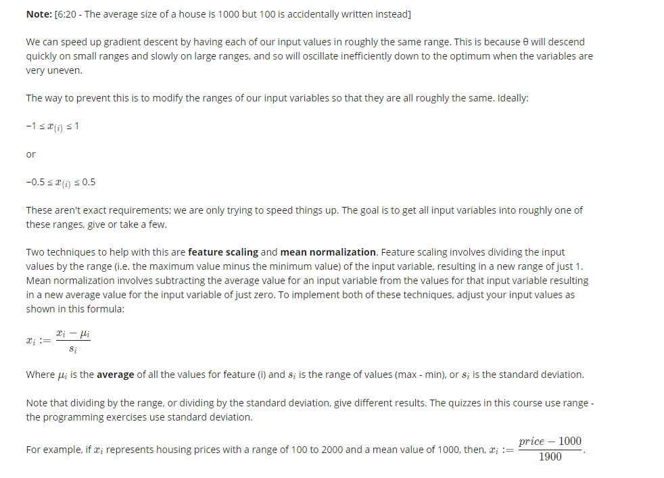

Gradient Descent in Practice II - Learning Rate

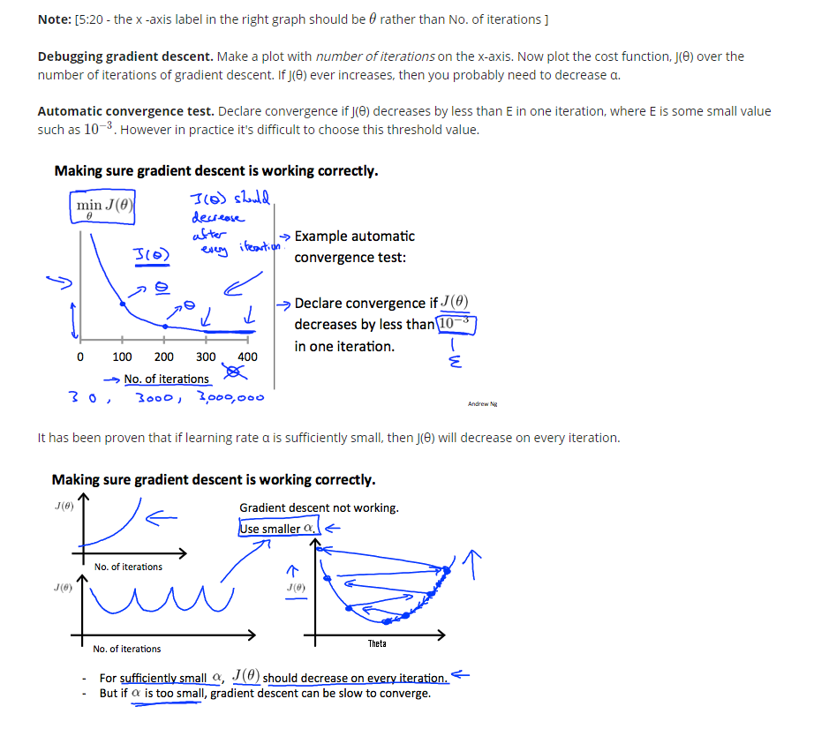

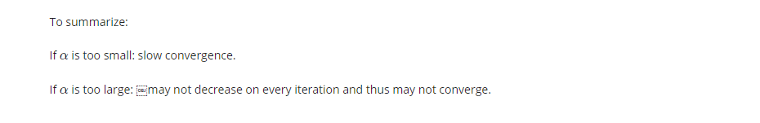

Features and Polynomial Regression

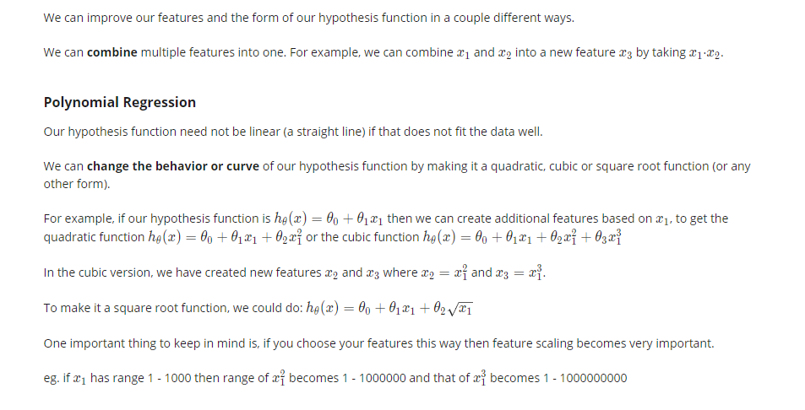

Normal Equation

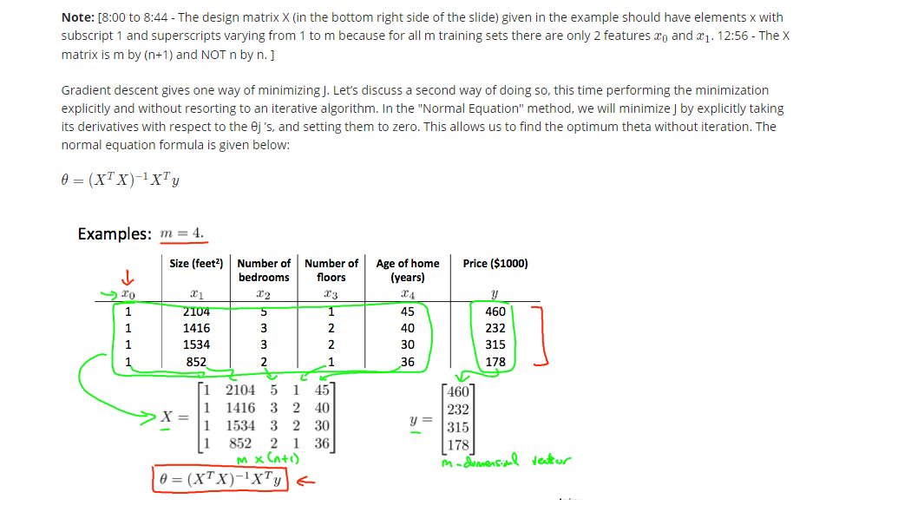

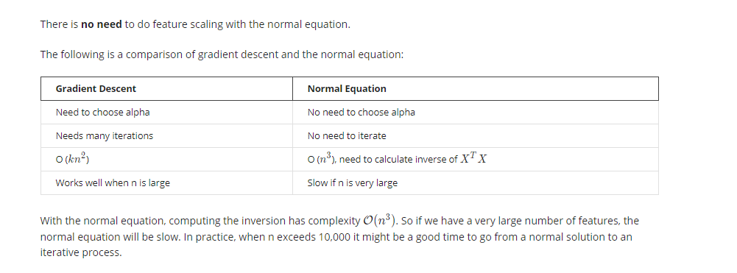

Normal Equation Noninvertibility

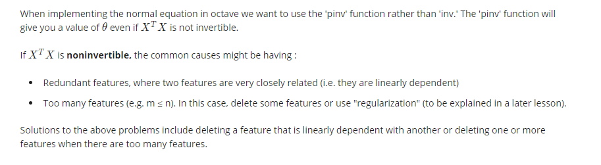

## Week3

Classification

To attempt classification, one method is to use linear regression and map all predictions greater than 0.5 as a 1 and all less than 0.5 as a 0. However, this method doesn't work well because classification is not actually a linear function.

The classification problem is just like the regression problem, except that the values we now want to predict take on only a small number of discrete values. For now, we will focus on the **binary classification** **problem** in which y can take on only two values, 0 and 1. (Most of what we say here will also generalize to the multiple-class case.) For instance, if we are trying to build a spam classifier for email, then x^{(i)}*x*(*i*) may be some features of a piece of email, and y may be 1 if it is a piece of spam mail, and 0 otherwise. Hence, y∈{0,1}. 0 is also called the negative class, and 1 the positive class, and they are sometimes also denoted by the symbols “-” and “+.” Given x^{(i)}*x*(*i*), the corresponding y^{(i)}*y*(*i*) is also called the label for the training example.

Hypothesis Representation

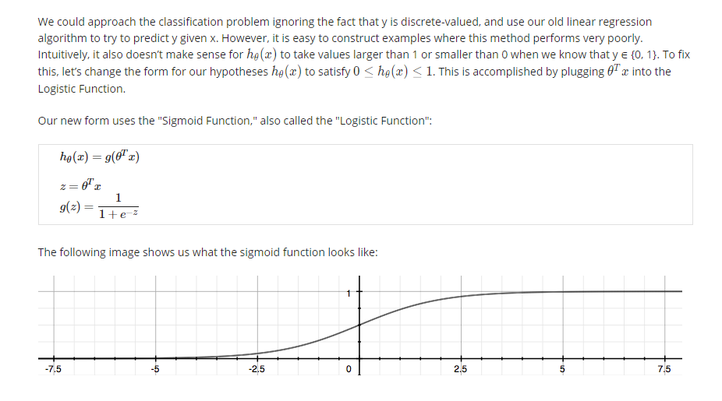

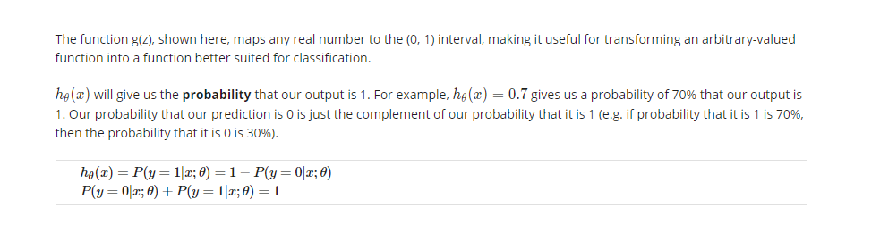

Decision Boundary

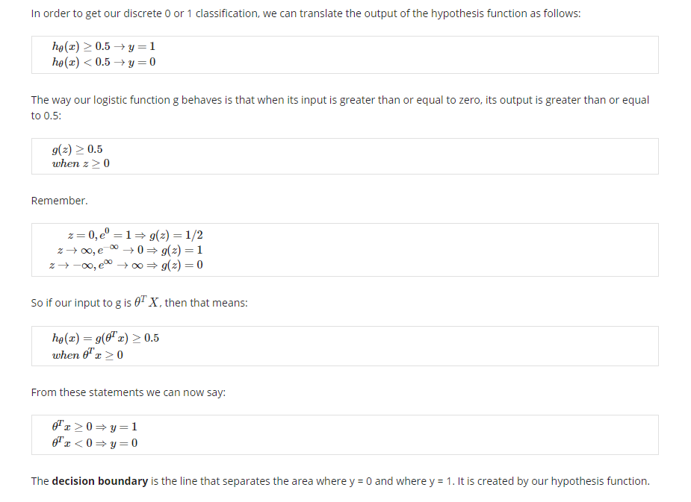

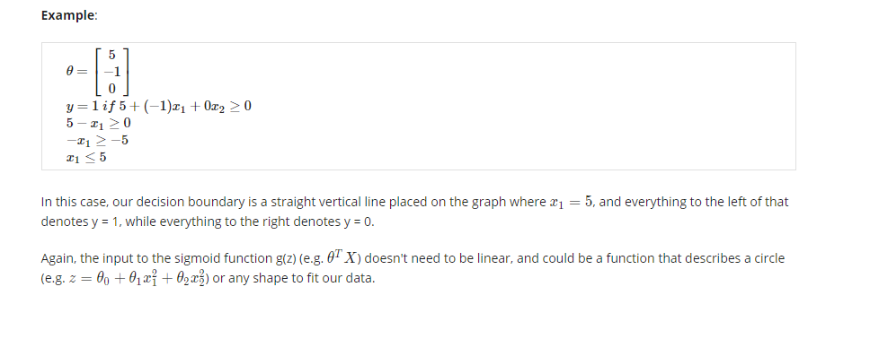

Cost Function

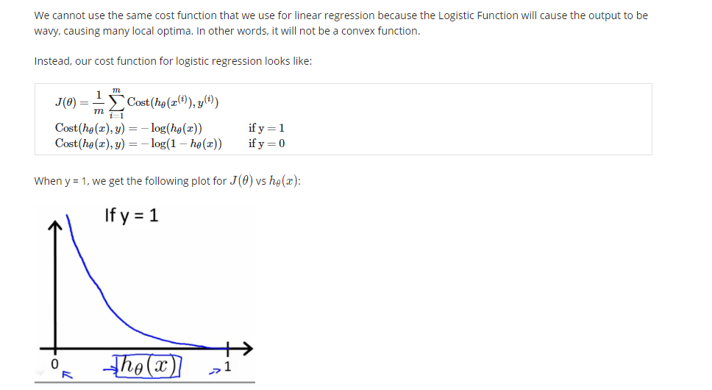

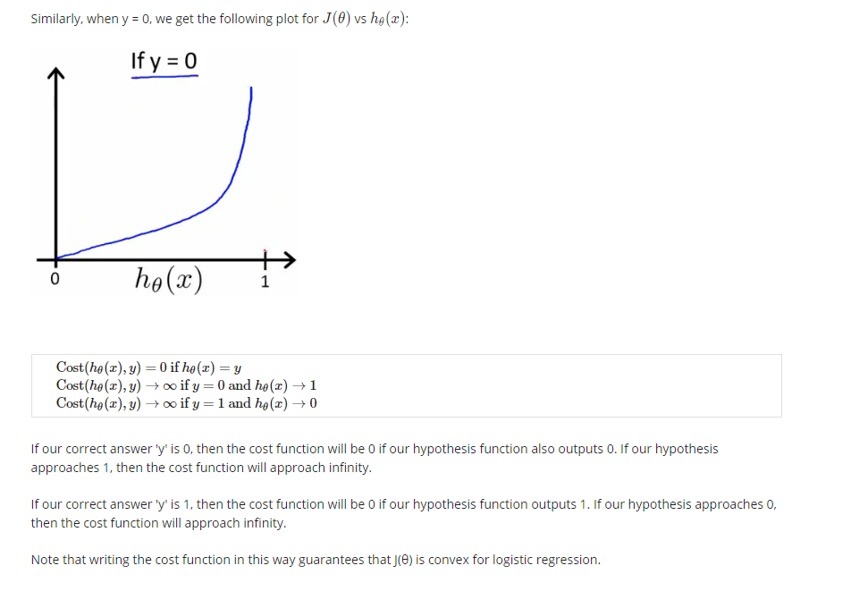

Simplified Cost Function and Gradient Descent

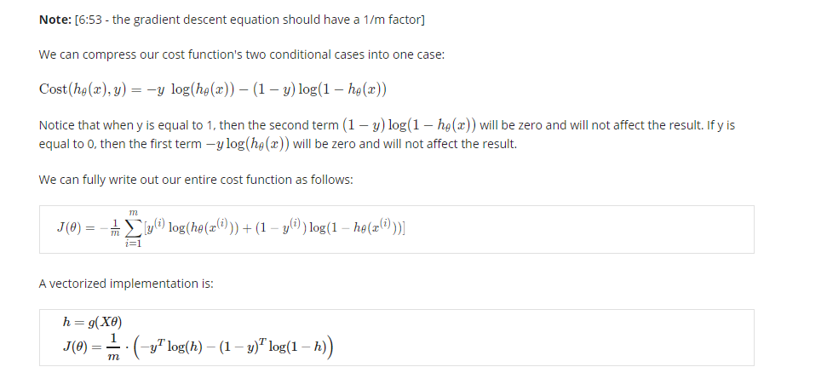

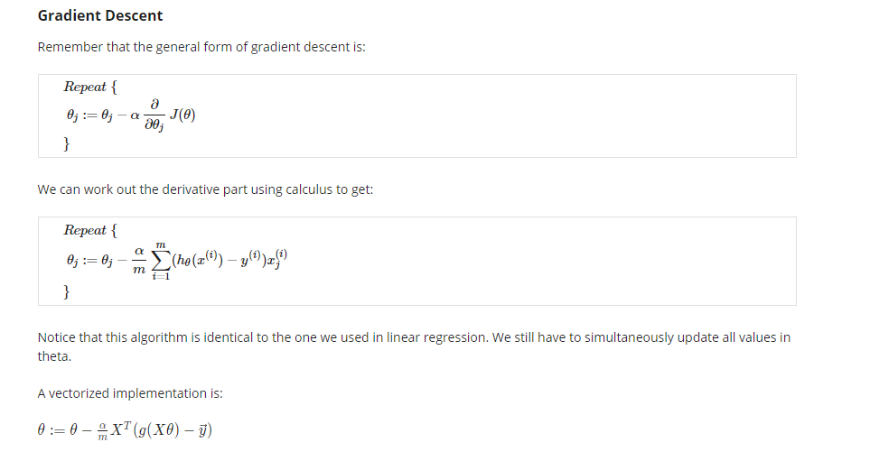

Advanced Optimization

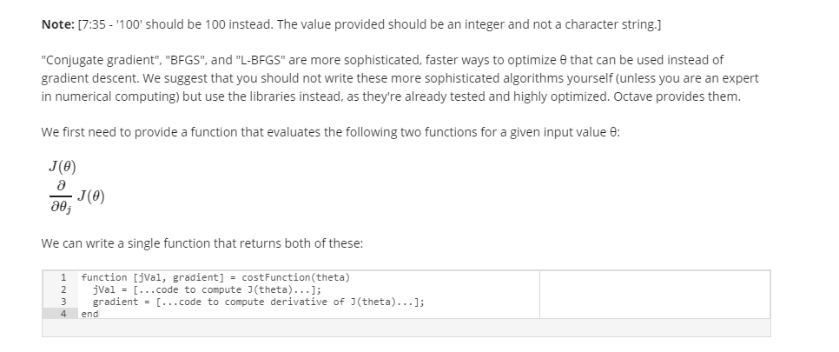

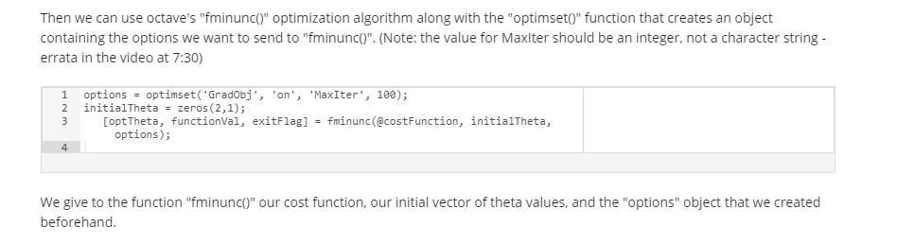

Multiclass Classification: One-vs-all

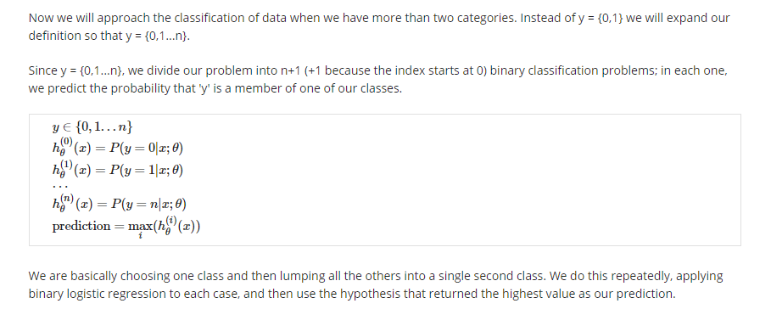

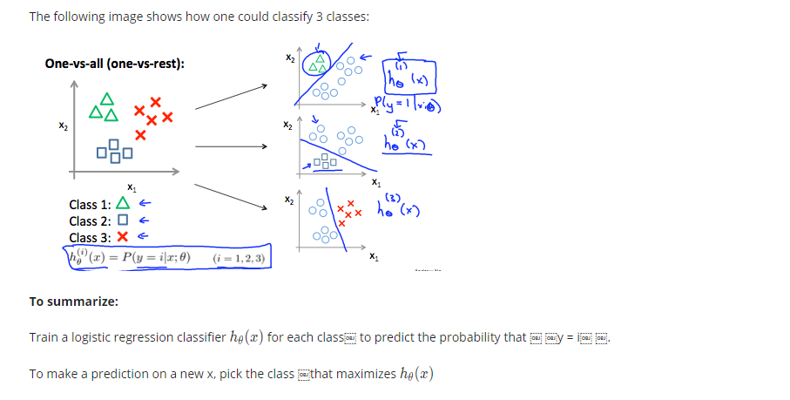

The Problem of Overfitting

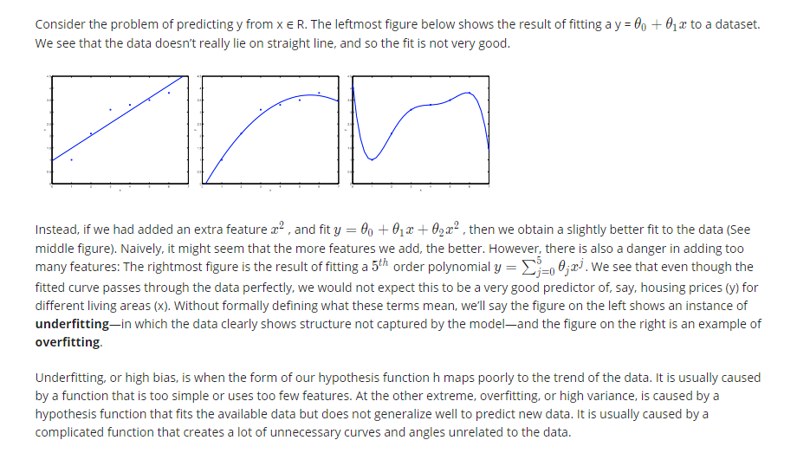

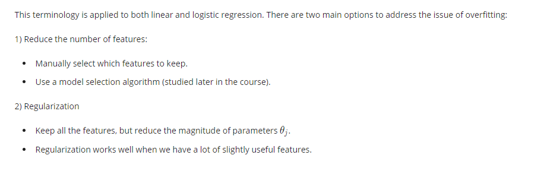

Cost Function

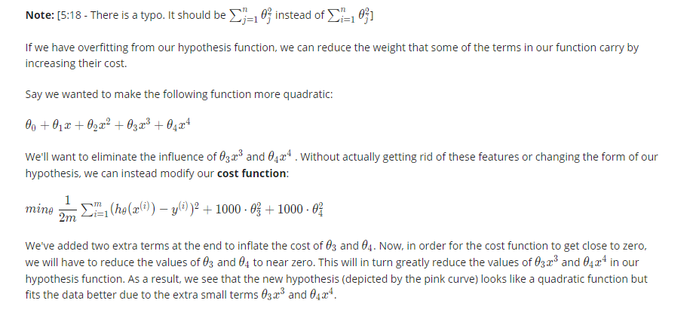

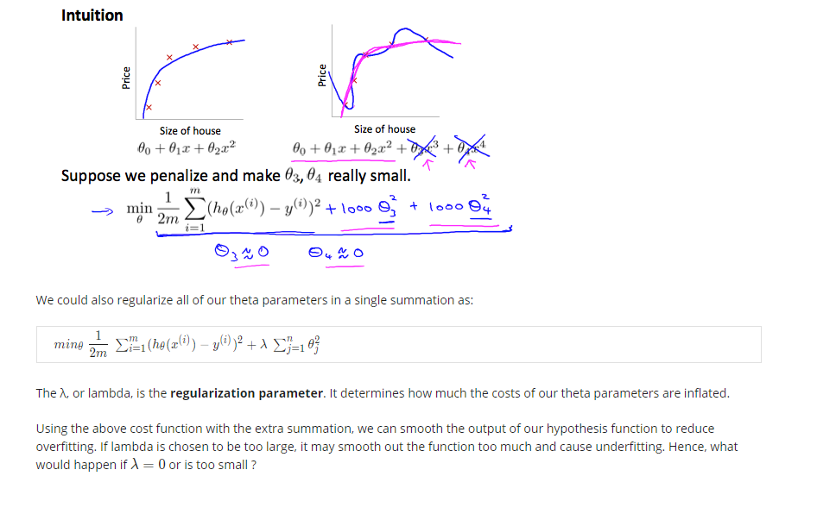

Regularized Linear Regression

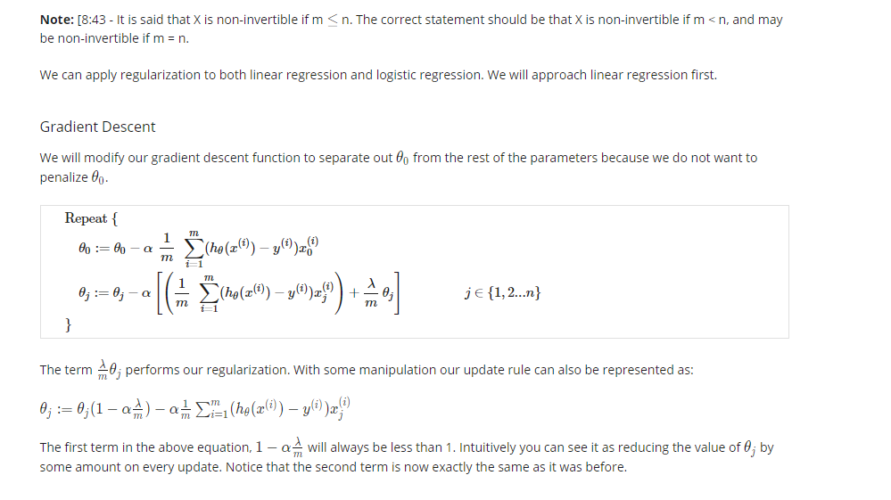

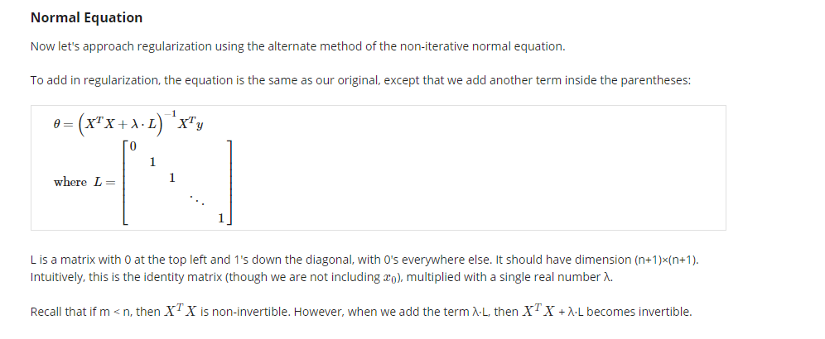

Regularized Logistic Regression

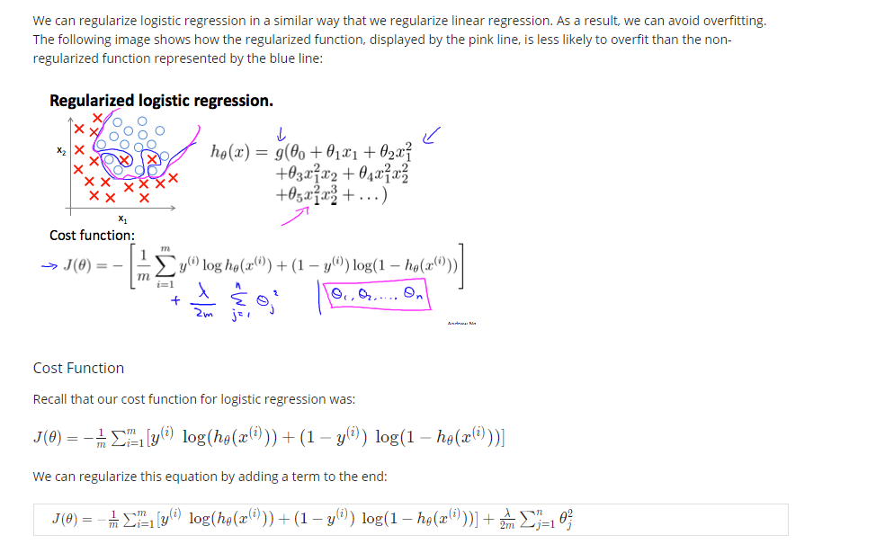

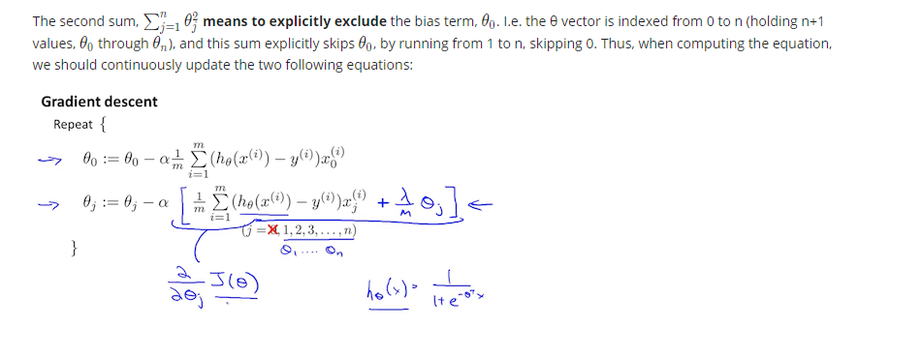

## Week4

Model Representation I

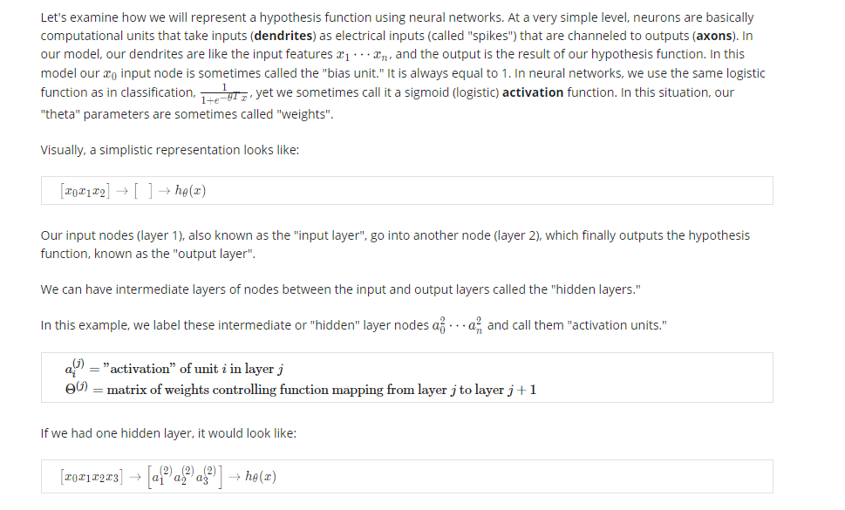

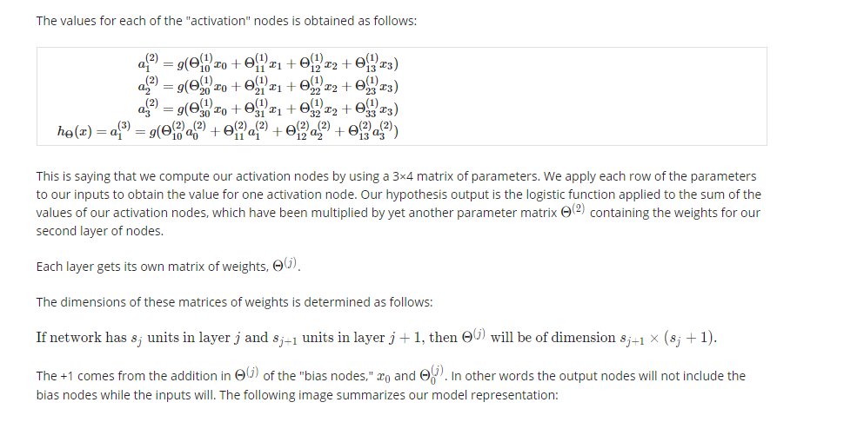

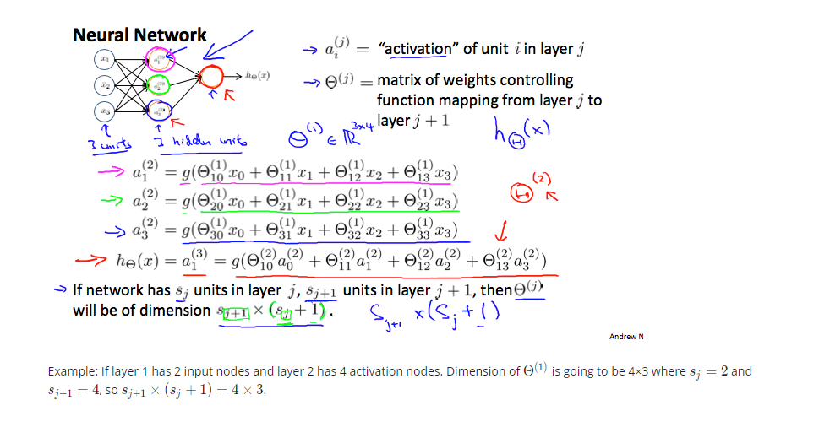

Model Representation II

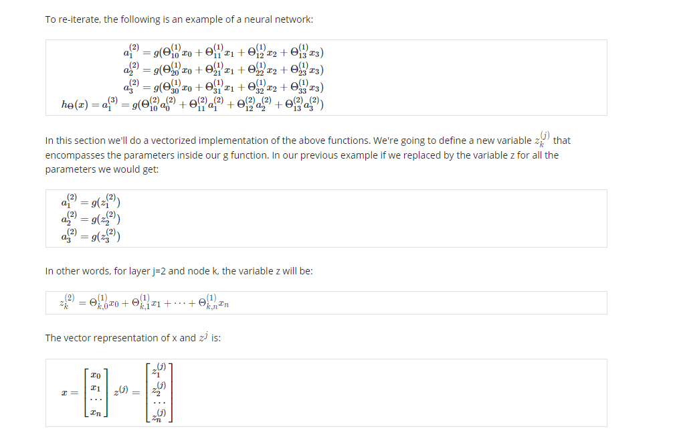

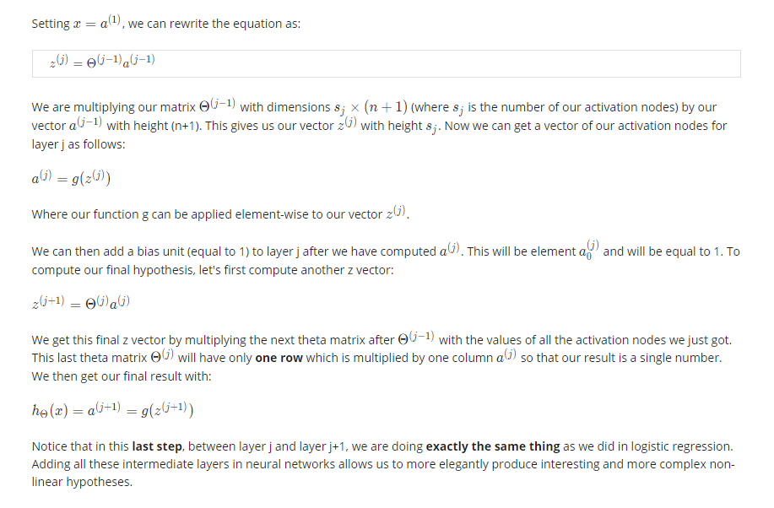

Examples and Intuitions I

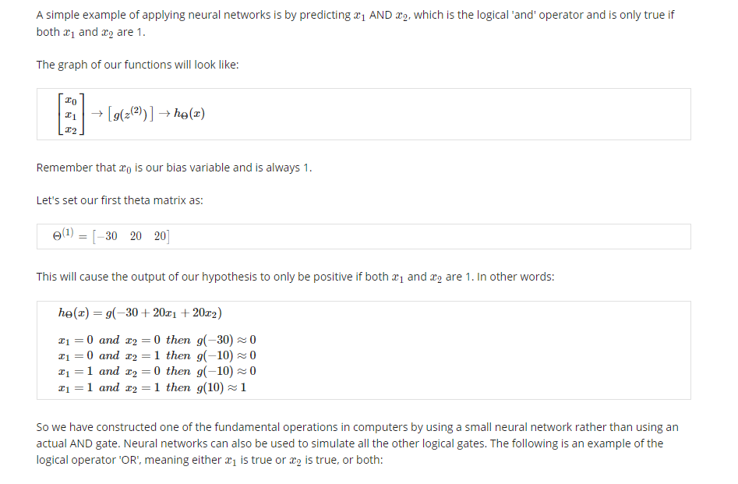

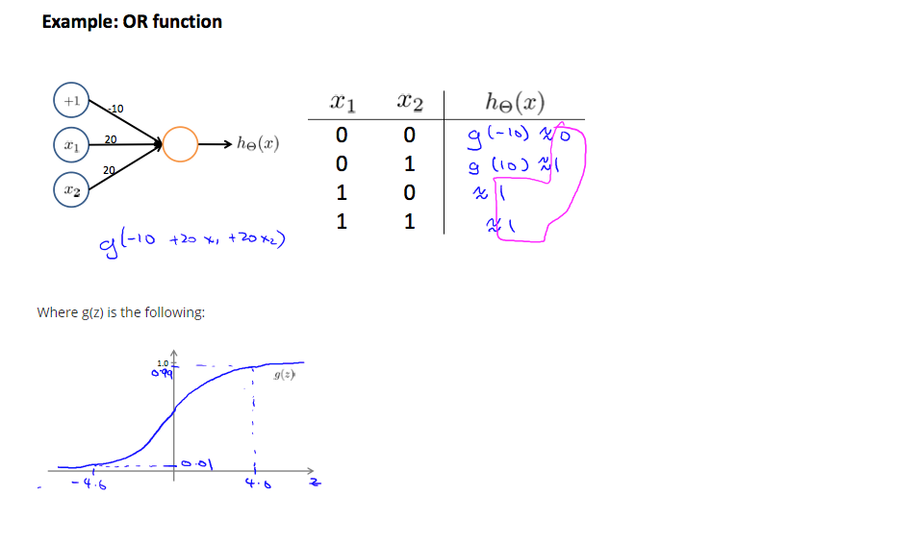

Examples and Intuitions II

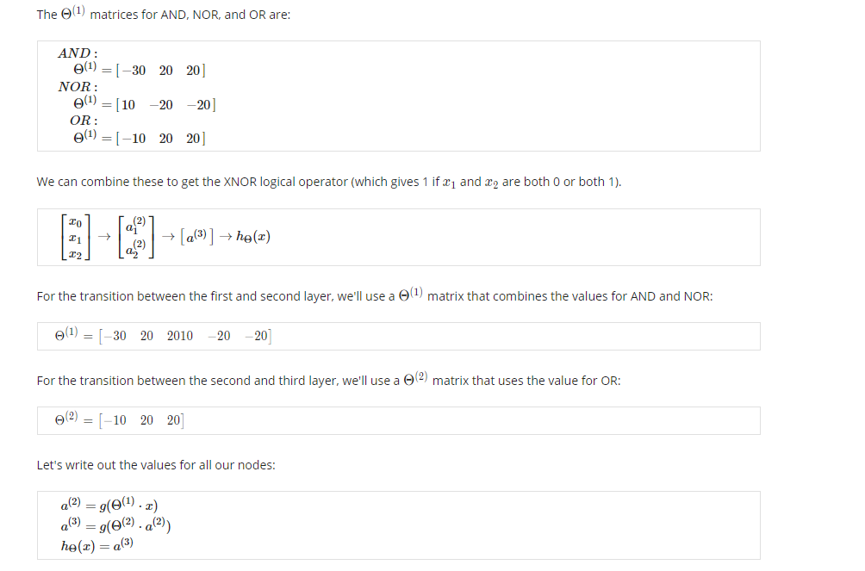

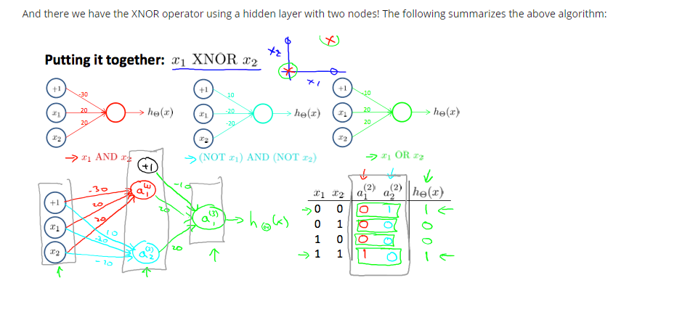

Multiclass Classification

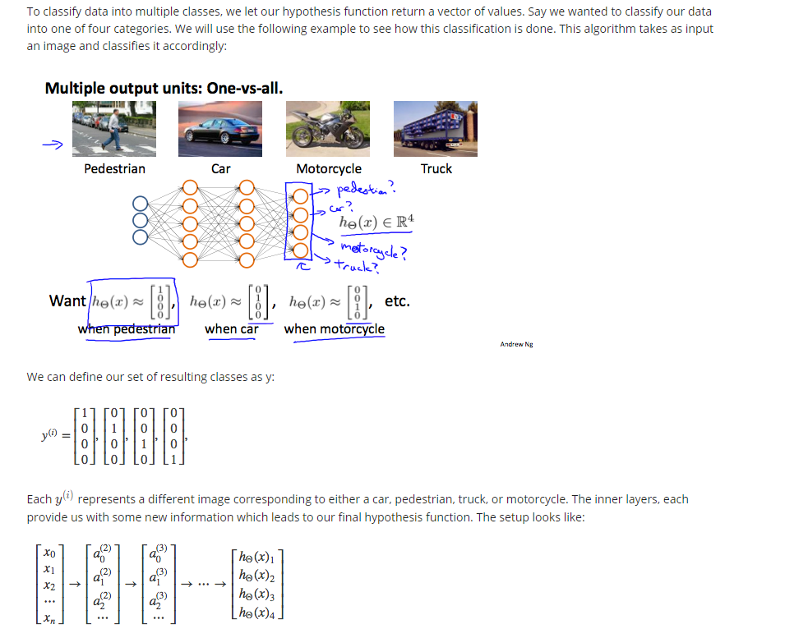

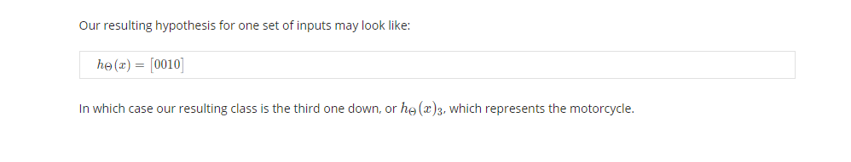

## Week5

Cost Function

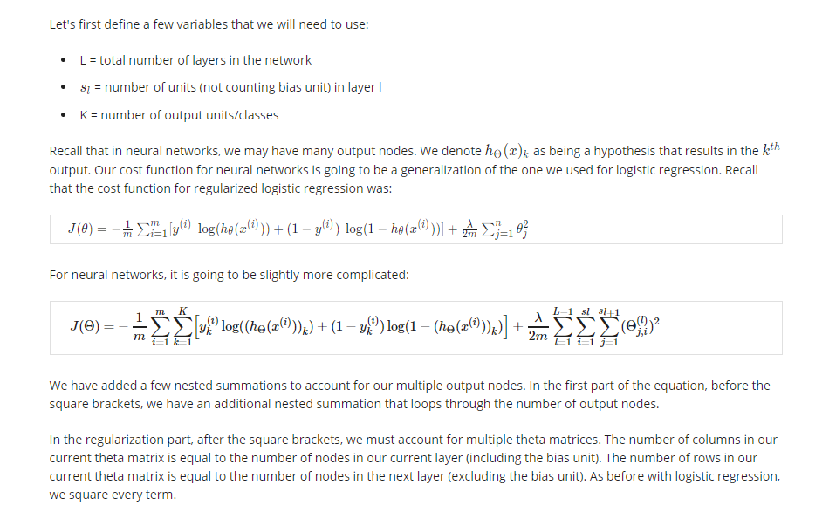

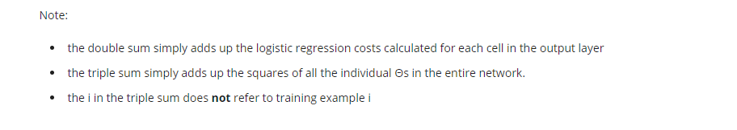

Backpropagation Algorithm

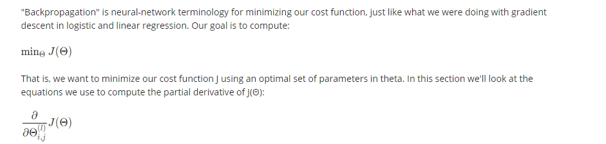

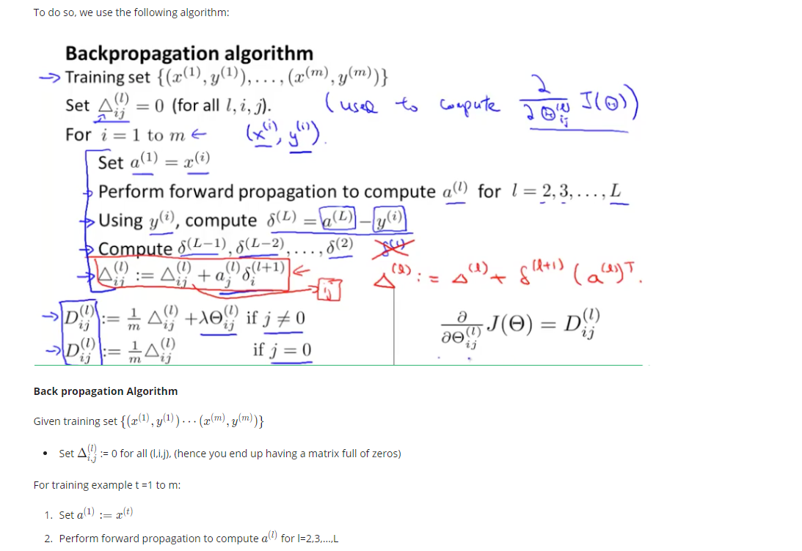

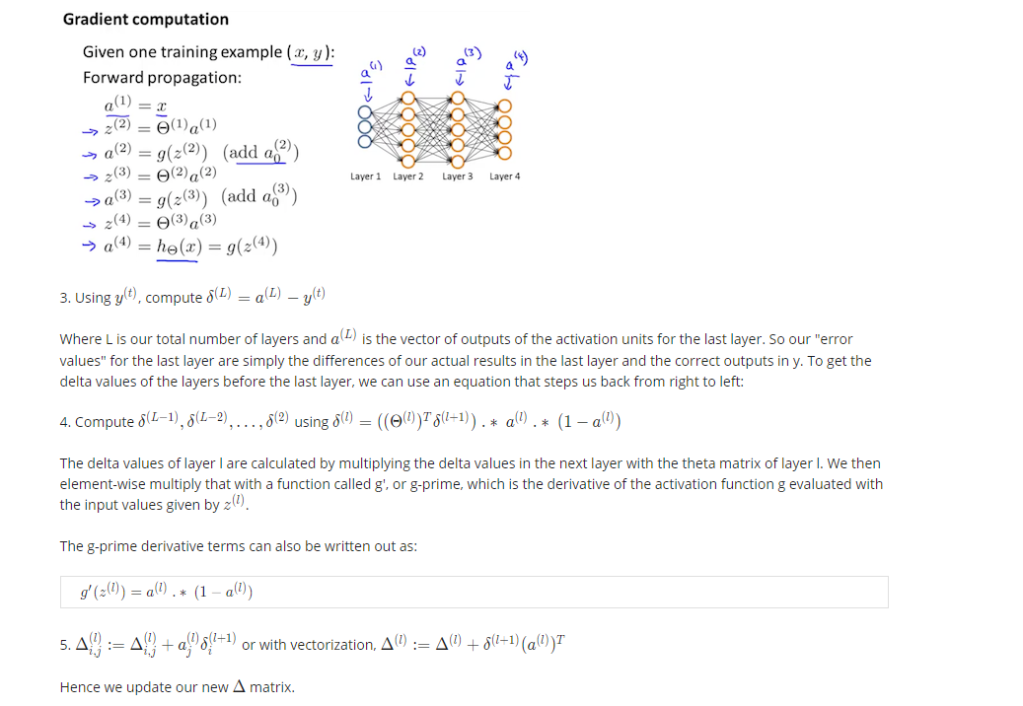

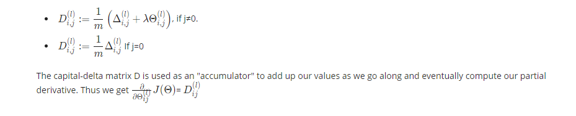

Backpropagation Intuition

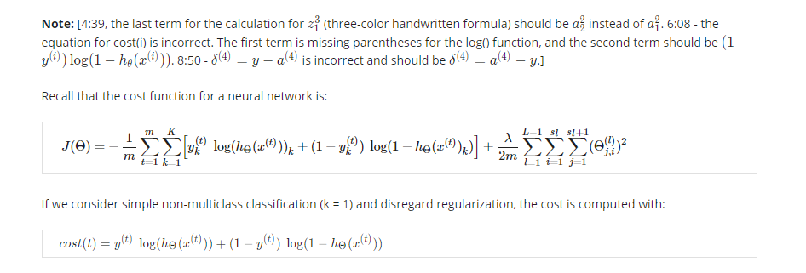

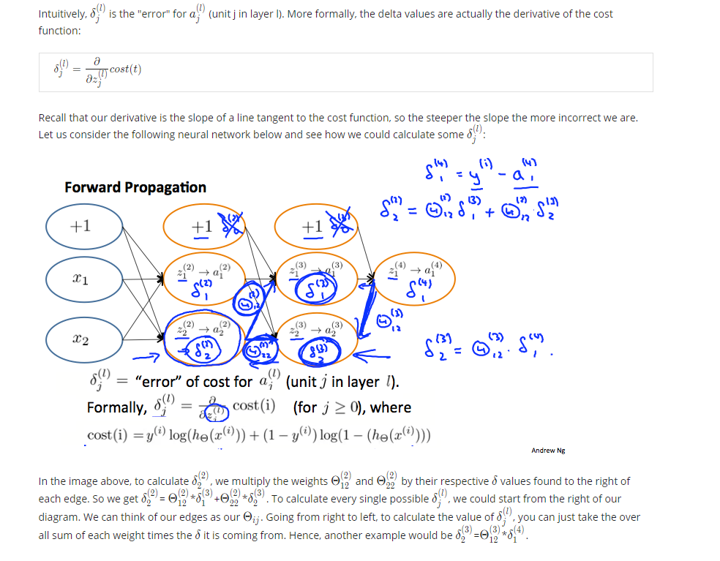

Implementation Note: Unrolling Parameters

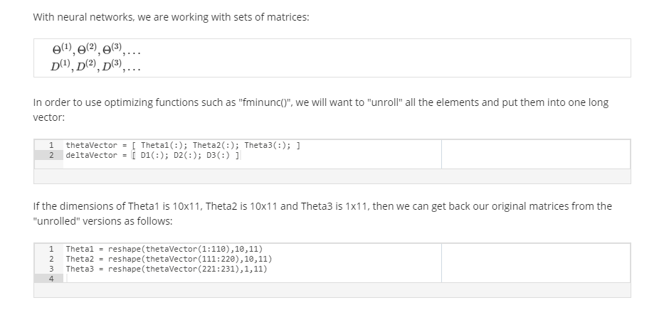

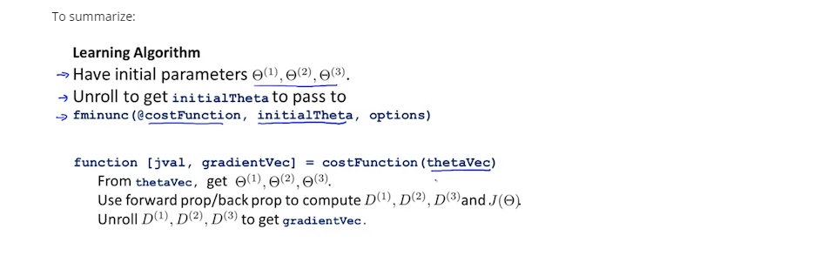

Gradient Checking

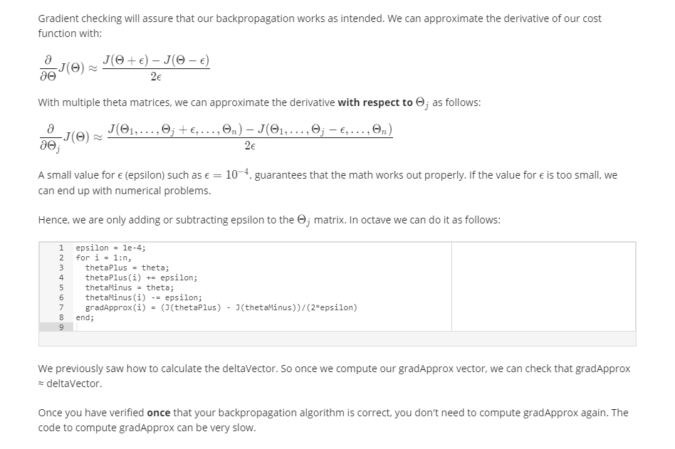

Random Initialization

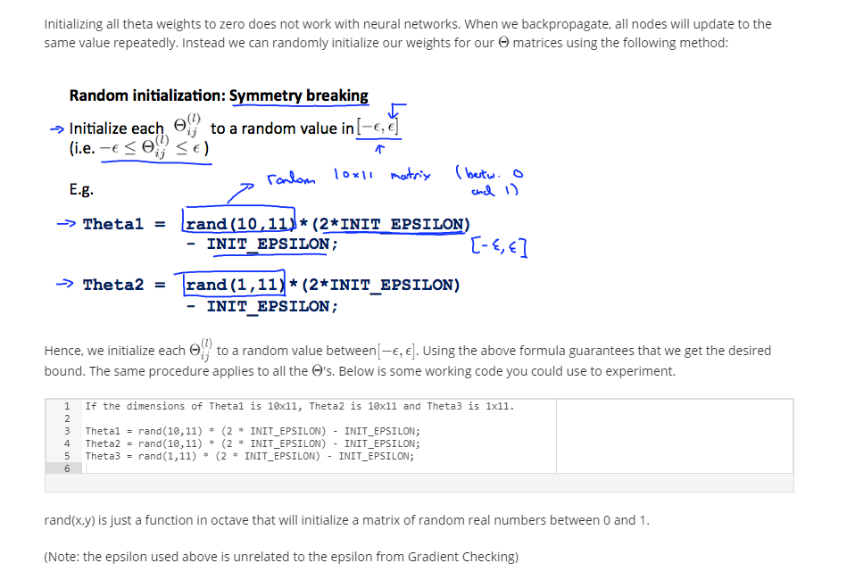

Putting it Together

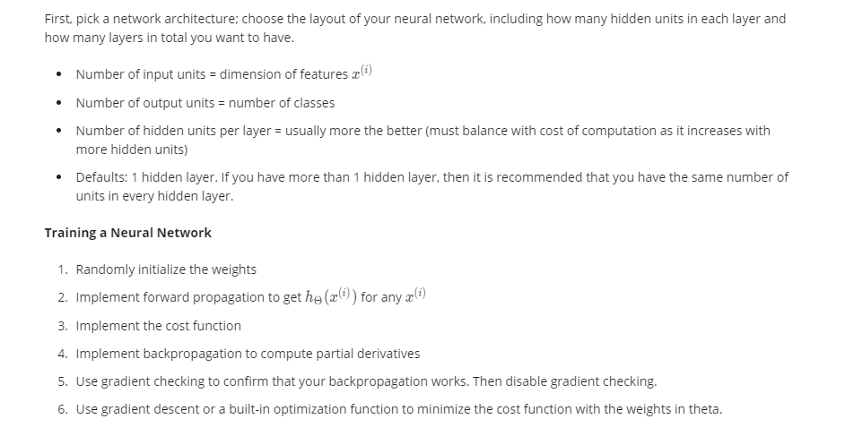

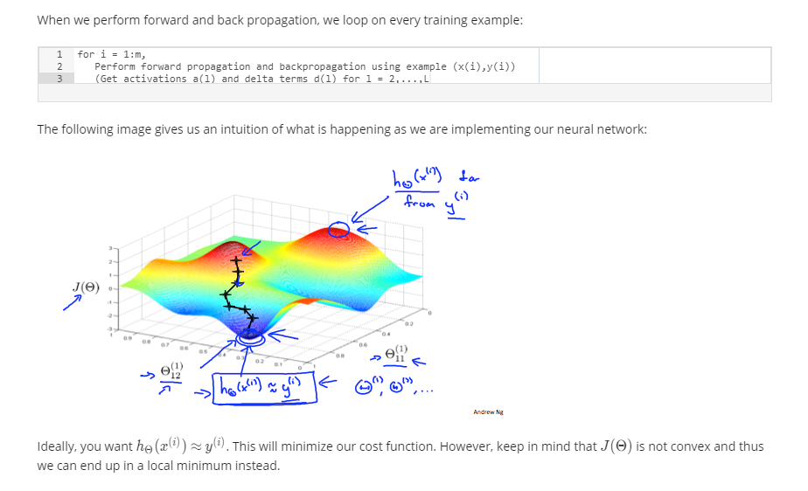

## Week6

Evaluating a Hypothesis

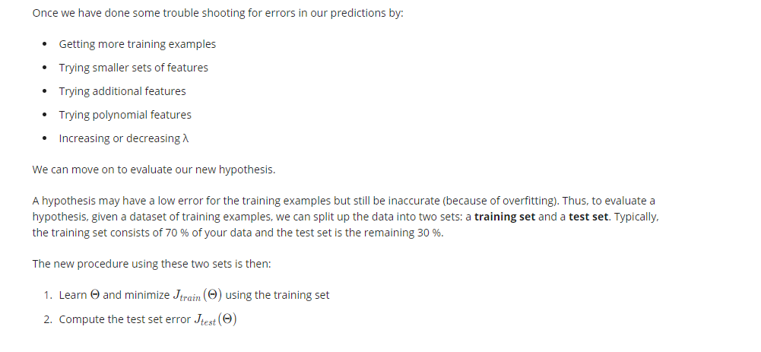

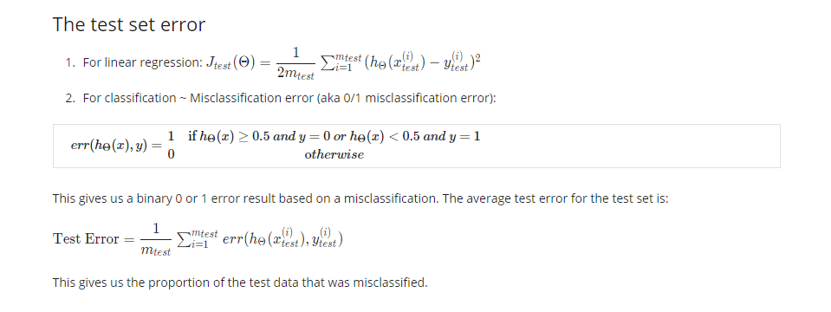

Model Selection and Train/Validation/Test Sets

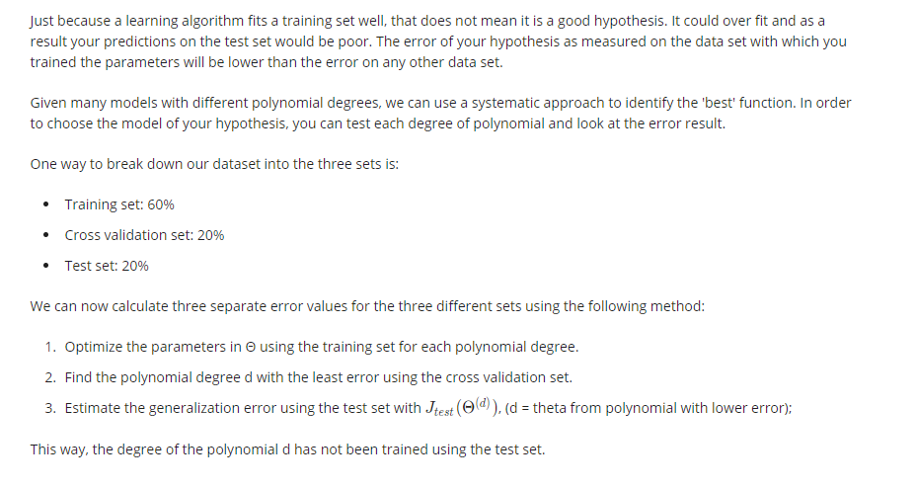

Diagnosing Bias vs. Variance

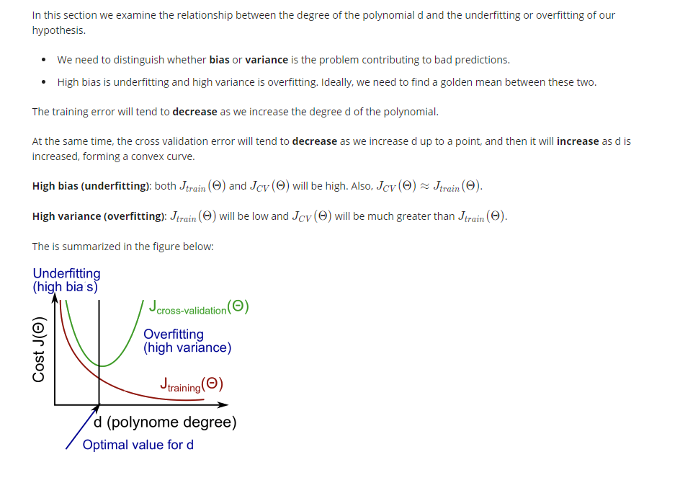

Regularization and Bias/Variance

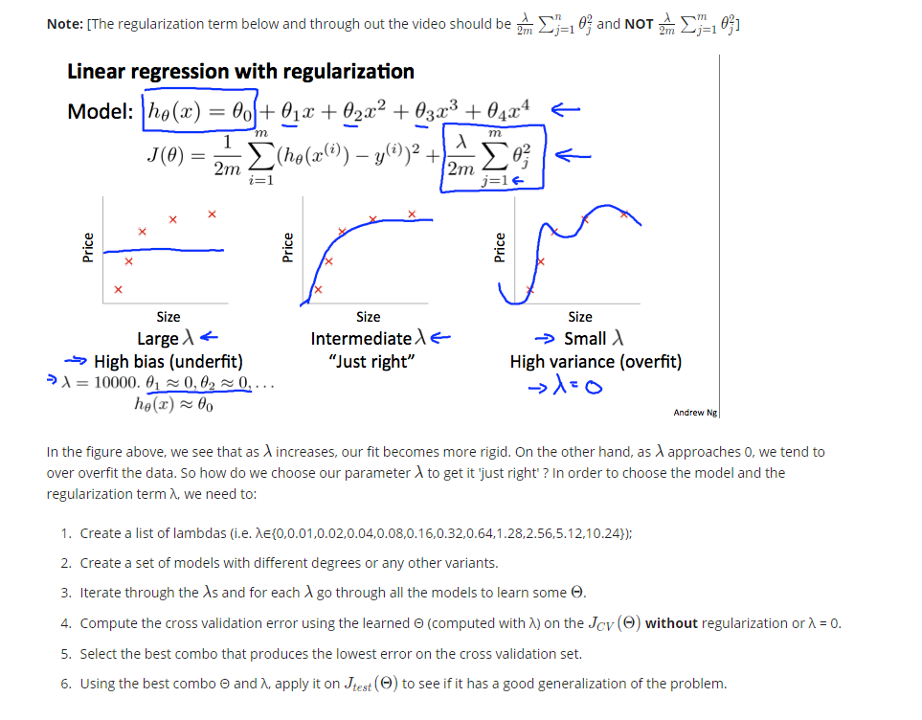

Learning Curves

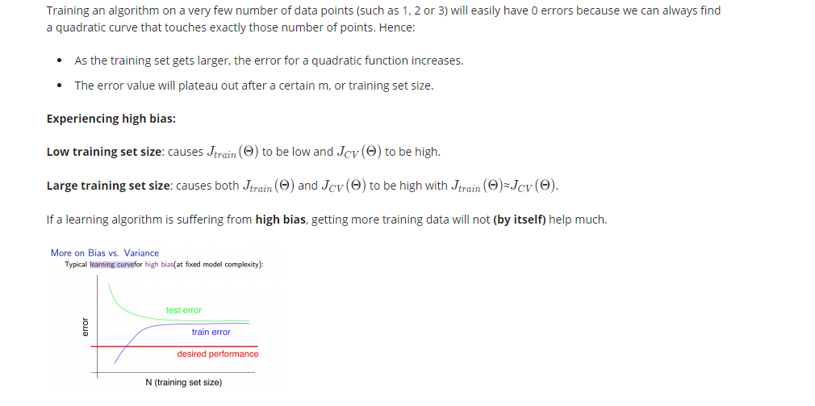

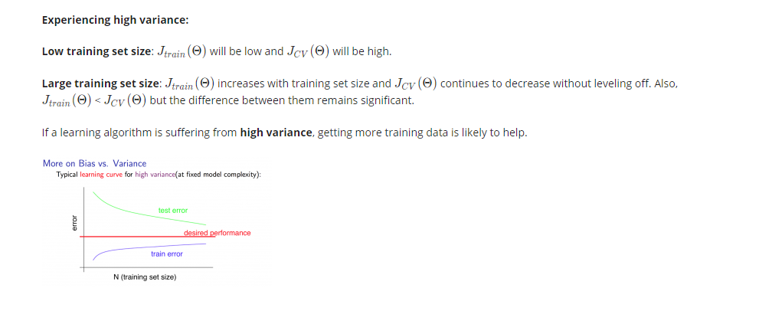

Deciding What to Do Next Revisited

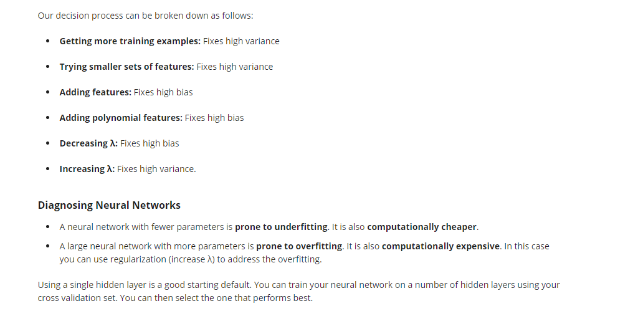

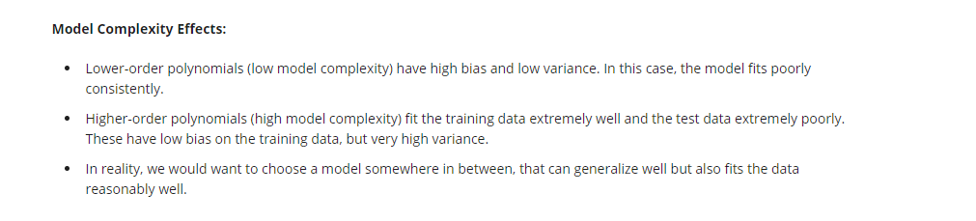

Prioritizing What to Work On

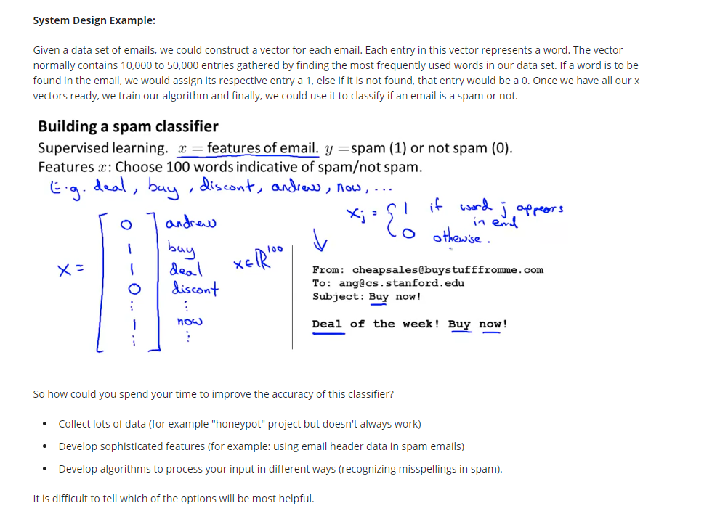

Error Analysis

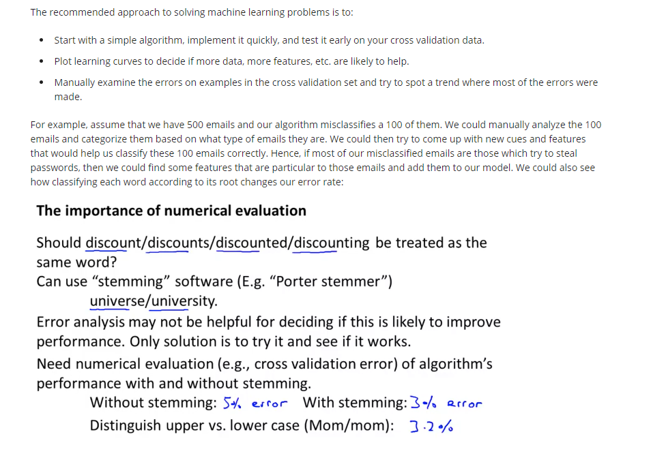

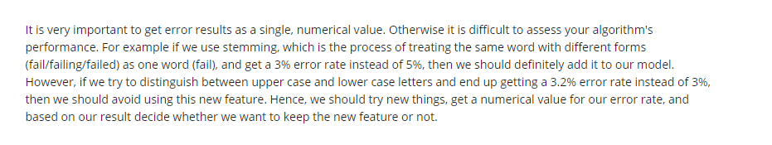

## Week7

None

## Week8

None

## Week9

None

## Week10

None

## Week11

None